Module I (Introduction)
Module I. Introduction to Arduino IDE
Objective: Understand what the Arduino IDE is, what it is used for, and how to navigate its interface.

Part I. Installation of Arduino IDE version 2.x.x
Procedures:
- Access the official Arduino website ( https://www.arduino.cc/en/software/ ) and download the software installation package appropriate for your operating system (Windows or macOS)
- Once installed, launch the application by Double Clicking the Arduino IDE icon. 
- Inspect the interface of the Arduino IDE.
a. Sketch Editor: The main text area where you write your code (called a Sketch).
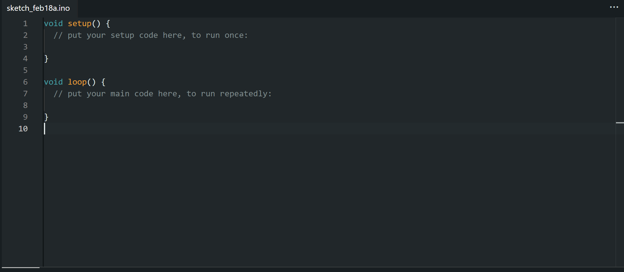
b. Toolbar: Contains primary tools to Verify (compile) your code and Upload it to the board.

c. Sidebar: Provides access to the Boards Manager, Library Manager, and Debug tools.
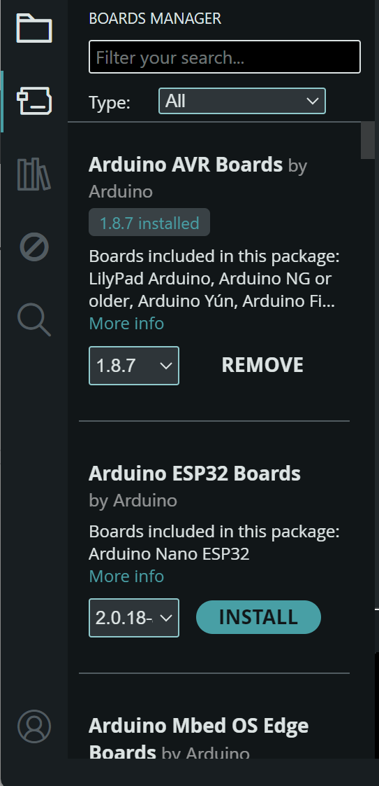
d. Output Console: Displays status messages, compilation errors, and memory usage details.
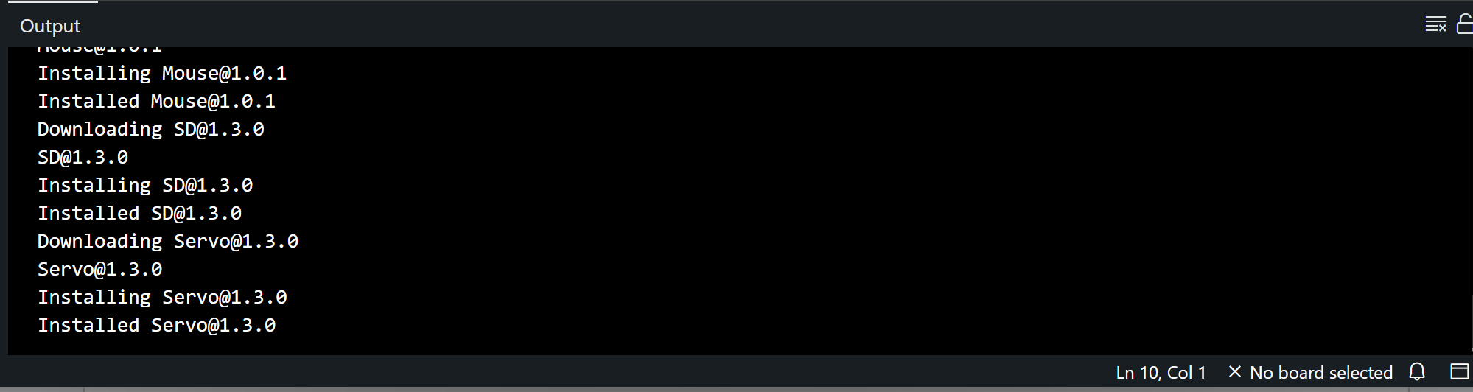

Module II (Blinking LED)
Module II. Blinking an LED with ESP32
Objective: Configure the Arduino IDE for the ESP32 board, write a basic sketch, and upload it to control the on-board LED or external LED.

Part I. Understanding the Components
To build this circuit, you will need the following parts:
- ESP32 Development Board (30 or 38 pins).
- LED (Light Emitting Diode): Has a long leg (Anode/+) and a short leg (Cathode/-).
- 220Ω Resistor: Limits the current flowing to the LED to prevent it from burning out.
- Breadboard & Jumper Wires: For making temporary connections.

Part II. Installing the ESP32 Board Package in Arduino IDE
Procedures:
- Click the Board Manager icon on the left sidebar (looks like a small circuit board).
- In the search bar, type ESP32.
- Find the entry titled esp32 by Espressif Systems and click Install. Wait for the progress bar to finish; this downloads the compilers and tools needed for the ESP32 chip.
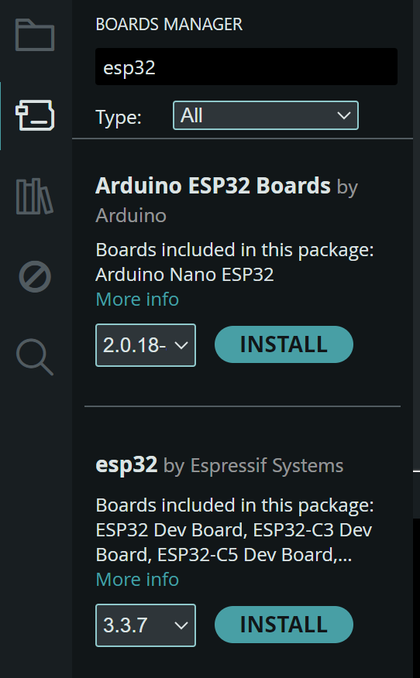

Part III. Hardware Assembly (The Circuit)
Procedures:
- Place the ESP32 board onto the breadboard.
- Connect the short leg (Cathode) of the LED to a Ground (GND) pin on the ESP32 using a jumper wire.
- Connect the long leg (Anode) of the LED to one end of the 220Ω resistor.
- Connect the other end of the resistor to GPIO 13 (labeled D13 or G13) on the ESP32
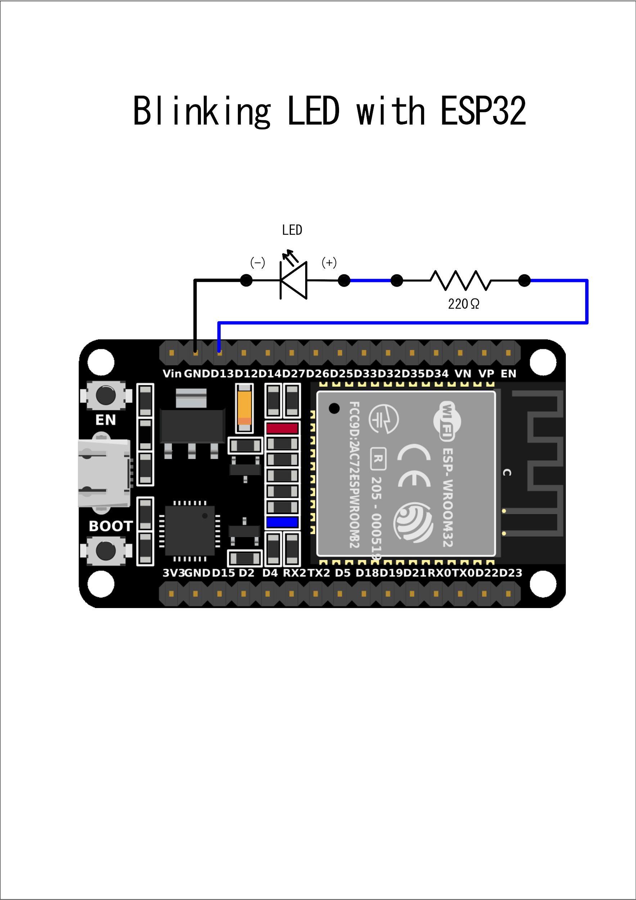

Note: We use a resistor because the ESP32 outputs 3.3V, which is high enough to damage a standard LED if connected directly.

Part IV. Writing the Blink Code
Procedures:
- Open your Arduino IDE.
- Connect your ESP32 board to your computer via a USB-C data cable.
- Select your board: Go to Toolbar > Select Board > ESP32 DEV MODULE
- Clear any existing code in the editor and paste the following "Blink" script.
// Define the LED pin
const int ledPin = 13;

void setup() {
// Initialize the digital pin as an output
pinMode(ledPin, OUTPUT);
}

void loop() {
digitalWrite(ledPin, HIGH); // Turn the LED ON
delay(1000); // Wait for 1000 milliseconds (1 second)
digitalWrite(ledPin, LOW); // Turn the LED OFF (0V)
delay(1000); // Wait for 1 second
}

Part V. Compiling and Uploading
Procedures:
- Click the Upload button (the right-pointing arrow) in the top toolbar.
- The "Boot" Button Trick: If you see a message saying Connecting......._____....., press and hold the BOOT button on your physical ESP32 board until the upload starts (you will see percentage numbers).
- Once the console displays "Done uploading," your external LED should begin to pulse.

Module III (PWM)
Module III. Pulse Width Modulation (PWM)
Objective: Understand how to simulate analog output (variable voltage) using digital pins to control the brightness of an LED.

Part I. The Concept of PWM
Digital pins are usually binary: they are either ON (3.3V) or OFF (GND). Pulse Width Modulation (PWM) is a technique where we flip the pin ON and OFF so fast that the connected device (like an LED) perceives it as a steady, intermediate voltage.
- Duty Cycle: The percentage of time the signal is "HIGH" vs. "LOW" during one cycle.
  - 0% Duty Cycle: Always OFF (0V).
  - 50% Duty Cycle: ON half the time (Simulates ~1.65V).
  - 100% Duty Cycle: Always ON (3.3V).

Part II. Hardware Assembly
We will use the same setup as the LED module, but we will use a PWM-capable pin. On the ESP32, almost all pins can provide PWM signals.
Procedures:
- Connect the Long leg (Anode) of an LED to a 220Ω resistor.
- Connect the other end of the resistor to GPIO 5.
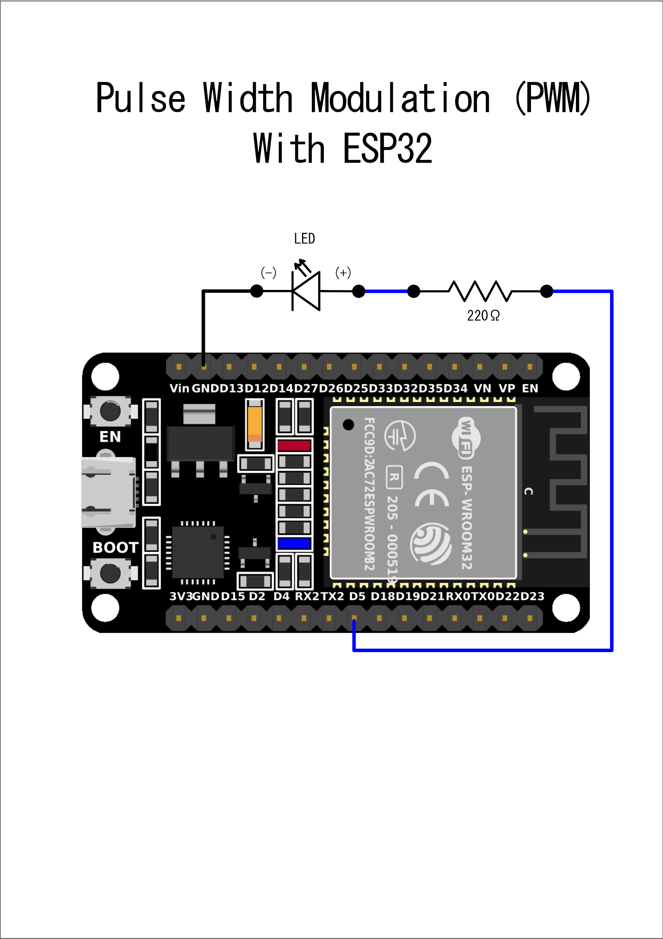
- Connect the Short leg (Cathode) of the LED to GND.

Part III. The Implementation Code
In the modern Arduino ESP32 core, you can use the standard analogWrite() function. The resolution is 8-bit, meaning the brightness range is from 0 (OFF) to 255 (Full Brightness).
/*
* Module VI: Pulse Width Modulation (PWM)
* Fading an LED in and out
*/

const int ledPin = 5; // The pin the LED is connected to

void setup() {
// No special setup required for analogWrite on modern ESP32 cores
pinMode(ledPin, OUTPUT);
}

void loop() {
// 1. Fade IN: Gradually increase brightness from 0 to 255
for (int brightness = 0; brightness <= 255; brightness++) {
analogWrite(ledPin, brightness);
delay(10); // Wait 10ms to make the fade visible
}

// 2. Fade OUT: Gradually decrease brightness from 255 to 0
for (int brightness = 255; brightness >= 0; brightness--) {
analogWrite(ledPin, brightness);
delay(10);
}
}

Part IV. Execution & Observation
Procedures:
- Upload the code to your ESP32.
- Observe the LED. It should "breathe"—slowly getting brighter and then slowly dimming.
- Experiment: Change the delay(10) to delay(2). The LED will breathe much faster.

Module IV (LDR)

Module IV. Ambient Light Monitoring with an LDR
Objective: Interface an LDR (Photoresistor) with the ESP32’s Analog-to-Digital Converter (ADC) using a voltage divider circuit to measure ambient light levels and map the raw data into usable instrumentation metrics.

Part I. Understanding the Instrumentation
Microcontrollers cannot measure resistance directly; they can only measure voltage. Because an LDR changes its resistance based on light exposure (high resistance in the dark, low resistance in the light), we must pair it with a fixed resistor to create a Voltage Divider. This converts the changing resistance into a changing voltage that the ESP32's analog pins can read.
Components Required:
- ESP32 Development Board
- LDR (Light Dependent Resistor / Photoresistor)
- 10kΩ Resistor (Fixed resistor for the voltage divider)
- Breadboard & Jumper Wires

Part II. Wiring the Components Procedures:
- Place the LDR on the breadboard.
- Connect one leg of the LDR to the 3.3V pin on the ESP32.
- Connect the other leg of the LDR to a blank row on the breadboard.
- From that same row (the junction), connect one leg of the 10kΩ Resistor.
- Connect the other leg of the 10kΩ Resistor to the GND (Ground) pin on the ESP32.
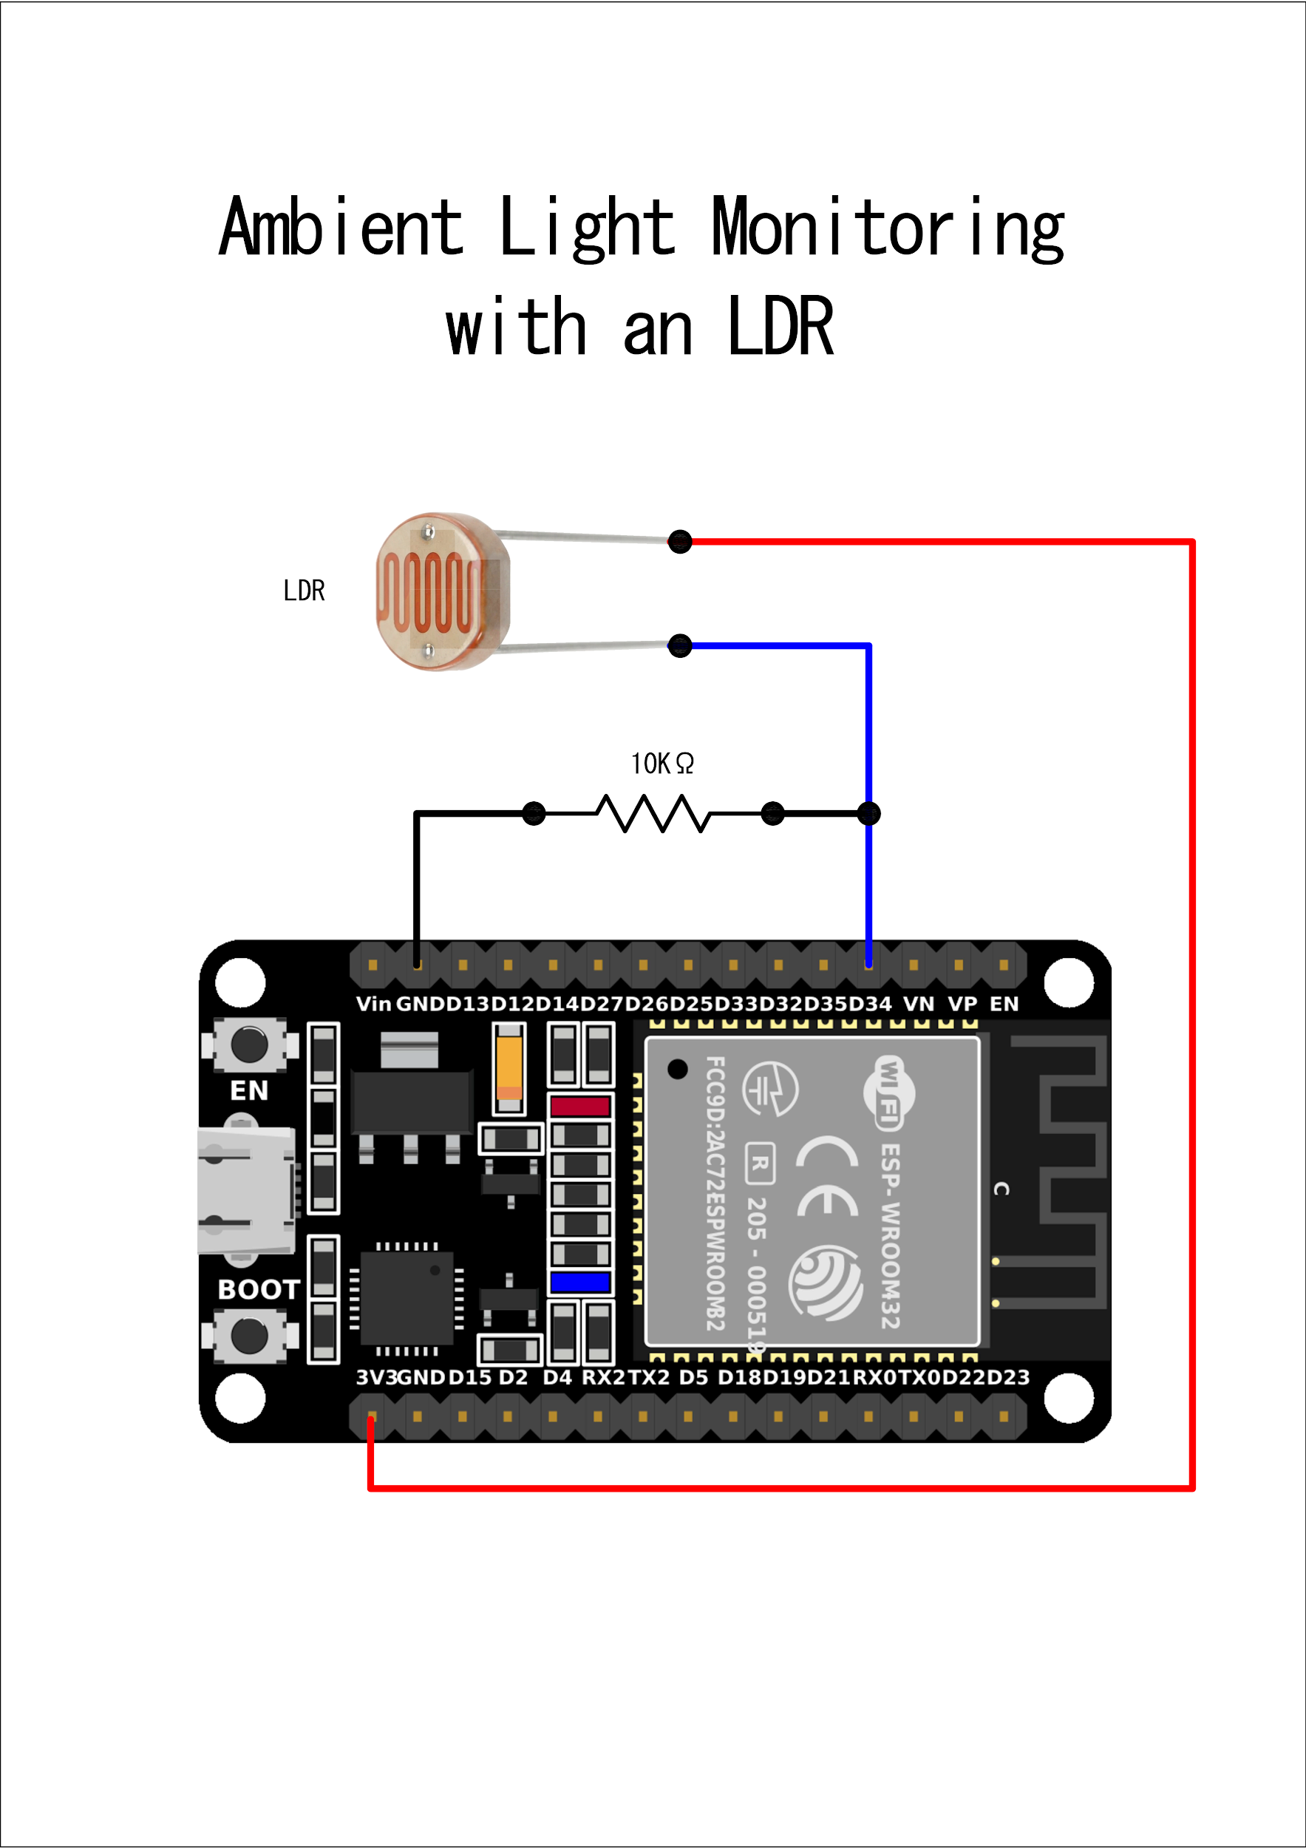
- Connect a jumper wire from the junction (where the LDR and 10kΩ resistor meet) to an analog input pin on the ESP32, such as Pin 34.

Part III. The Sketch (Code)
The ESP32 has a 12-bit ADC, meaning it reads voltages and converts them into a numeric value between 0 (0 Volts) and 4095 (3.3 Volts).
Procedures:
- Open a new sketch in the Arduino IDE.
- Copy the code below into your Sketch Editor.
- Observe the use of the map() function, which is a crucial intermediate technique to convert raw, arbitrary ADC numbers into a readable 0-100 percentage scale.
// Define the analog pin connected to the LDR voltage divider
const int ldrPin = 34;

// Variable to store the raw analog reading
int rawLightValue = 0;

void setup() {
// Initialize serial communication at 115200 bits per second
Serial.begin(115200);

// ESP32 ADC resolution is 12-bit (0-4095) by default.
// Explicitly setting it ensures consistent readings.
analogReadResolution(12);

Serial.println("LDR Sensor Initialized...");
delay(1000);
}

void loop() {
// Read the analog value from the LDR pin
rawLightValue = analogRead(ldrPin);

// Map the raw 12-bit value (0-4095) to a percentage (0-100%)
// Note: Depending on your exact LDR and ambient lighting,
// you may need to adjust the 0-4095 bounds to calibrate your specific room.
int lightPercentage = map(rawLightValue, 0, 4095, 0, 100);

// Format the output for the Serial Monitor
Serial.print("Raw ADC Value: ");
Serial.print(rawLightValue);
Serial.print(" | Estimated Light Level: ");
Serial.print(lightPercentage);
Serial.println("%");

// Instrumentation Logic: Trigger an event based on a threshold
if (lightPercentage < 20) {
Serial.println("--> ALERT: Low light condition detected! (< 20%)");
} else if (lightPercentage > 85) {
Serial.println("--> ALERT: High glare/brightness detected! (> 85%)");
}

// Delay for half a second before taking the next reading
delay(500);
}

Part IV. Execution and Calibration Procedures:
- Verify and Upload the code to your ESP32.
- Open the Serial Monitor and set the baud rate to 115200.
- Observe the raw ADC values and the calculated percentage.
- Test the Sensor: Cover the LDR completely with your finger to simulate total darkness. Note the reading. Then, shine a smartphone flashlight directly onto the LDR and note the new reading.
- Calibration: If your lowest value is never 0 and your highest is never 4095, adjust the map(rawLightValue, lowest_observed, highest_observed, 0, 100) function in your code to accurately reflect your specific sensor's real-world environment.
- (Optional) Go to Tools > Serial Plotter in the Arduino IDE to view the light fluctuations as a real-time line graph.

Module V (HC-SR04)
Module V. Distance Measurement with Ultrasonic Sensor (HC-SR04)
Objective: Interface the HC-SR04 ultrasonic sensor with the ESP32 to measure distances. You will learn how sound waves are used for ranging and how to convert travel time into centimeters.

Part I. Understanding the HC-SR04 Sensor
The HC-SR04 works on the same principle as sonar or a bat's echolocation. It emits an ultrasonic pulse at 40kHz and travels through the air. If there is an object in its path, the pulse bounces back to the sensor.
- VCC: Power (Usually 5V for best performance).
- Trig (Trigger): Sends the ultrasonic pulse.
- Echo: Receives the bounced pulse.
- GND: Ground.

Part II. Hardware Wiring & Pin Selection
The HC-SR04 uses sound pulses to calculate distance. While the sensor usually needs 5V (Vin) to be accurate, its Echo pin sends back a 5V signal. The ESP32 pins are 3.3V, so using a simple voltage divider on the Echo pin is recommended for long-term safety, though many hobbyists connect it directly for quick tests..
Procedures:
- VCC: Connect to the Vin pin (this provides 5V from your USB).
- GND: Connect to any GND pin.
- Trig: Connect to GPIO 5 Trigger (Output).
- Echo (The Voltage Divider Path):
- Connect a 1kΩ resistor between the sensor's Echo pin and GPIO 18.
- Connect a 2kΩ resistor from GPIO 18 to a GND pin.

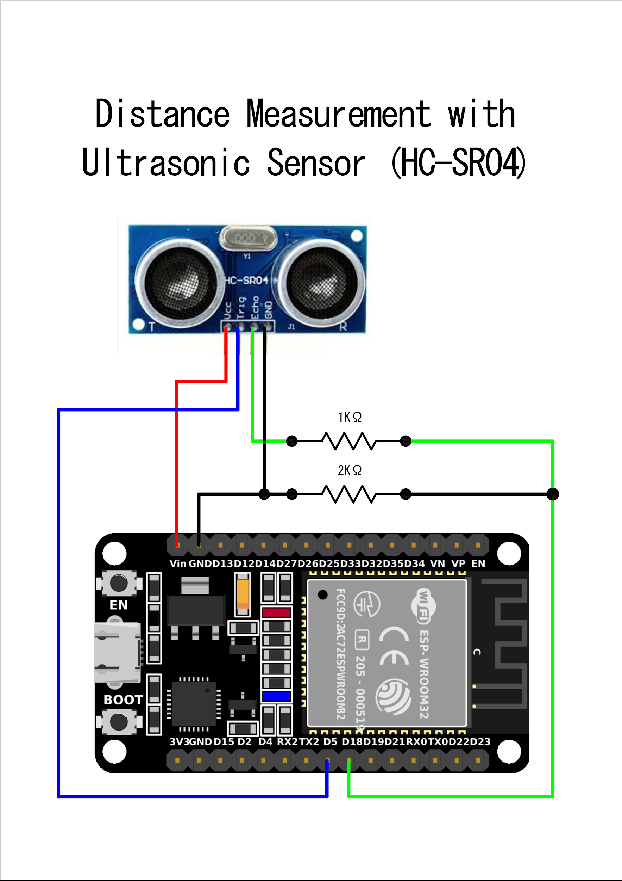

Part III. The Implementation Code
Copy this entire block into a new sketch in your Arduino IDE:
/*
* Module IV: Ultrasonic Distance Sensor (HC-SR04)
* Target Board: ESP32
*/

// 1. Pin Configuration
const int trigPin = 5; // Trigger Pin (Output)
const int echoPin = 18; // Echo Pin (Input)

// 2. Constants & Variables
#define SOUND_SPEED 0.034 // Speed of sound in cm/uS
long duration;
float distanceCm;

void setup() {
// Initialize Serial Monitor
Serial.begin(115200);

// Define Pin Modes
pinMode(trigPin, OUTPUT);
pinMode(echoPin, INPUT);
}

void loop() {
// 3. Clear the trigger pin
digitalWrite(trigPin, LOW);
delayMicroseconds(2);

// 4. Send a 10-microsecond pulse to trigger the sensor
digitalWrite(trigPin, HIGH);
delayMicroseconds(10);
digitalWrite(trigPin, LOW);

// 5. Read the Echo pulse (returns time in microseconds)
duration = pulseIn(echoPin, HIGH);

// 6. Calculate the distance
// Formula: Distance = (Time * Speed of Sound) / 2
distanceCm = duration * SOUND_SPEED / 2;

// 7. Output the data
if (duration == 0) {
Serial.println("Warning: No pulse received. Check wiring!");
} else {
Serial.print("Distance: ");
Serial.print(distanceCm);
Serial.println(" cm");
}

// Wait 500ms before the next scan
delay(500);
}



Part IV. Execution Procedures
- Select Port: Go to Tools > Port and ensure your ESP32 is selected.
- Upload: Click the Upload (Arrow) button. If you see Connecting......., press and hold the BOOT button on the board.
- Monitor: Open the Serial Monitor (magnifying glass icon) and ensure the baud rate is set to 115200.

Module VI (Potentiometer)

Module VI. Analog Input with Potentiometer
Objective: Understand how to read variable voltage using a Potentiometer and the ESP32’s Analog-to-Digital Converter (ADC). You will learn how to turn a physical knob into data the ESP32 can process.

Part I. Understanding the Potentiometer
A potentiometer (or "pot") is a three-terminal variable resistor. As you rotate the knob, the resistance changes, which varies the voltage output on the middle pin.
- Pin 1: Ground (GND).
- Pin 2 (Wiper): The signal pin that outputs a voltage between 0V and 3.3V.
- Pin 3: Power (VCC - 3.3V).

Part II. Hardware Assembly
Crucial Note on ESP32 Pins: Unlike the Arduino Uno (10-bit), the ESP32 has a 12-bit ADC. This means it converts the voltage into a range from 0 to 4095.
Procedures:
- Connect the left pin of the pot to GND.
- Connect the right pin of the pot to 3V3.
- Connect the middle pin (Wiper) to GPIO 34.
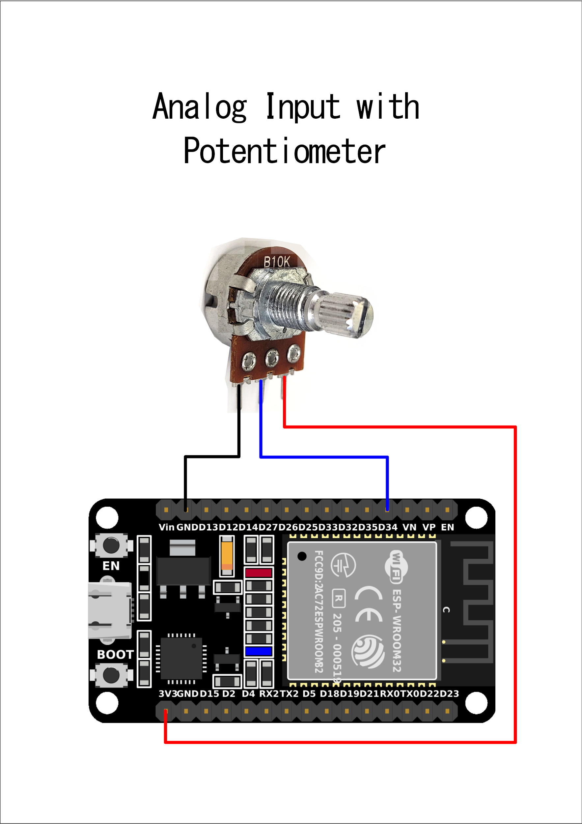
  - Note: GPIO 34 is an "Input Only" pin, making it ideal for sensors and pots.

Part III. The Implementation Code
This sketch reads the analog value from the potentiometer and prints both the raw value (0–4095) and the calculated voltage (0V–3.3V) to the Serial Monitor.

/*
* Module V: Potentiometer & ADC
* Target Board: ESP32
*/

// 1. Define the analog input pin
const int potPin = 34;

// 2. Variable to store the value
int potValue = 0;

void setup() {
// Initialize Serial Monitor at 115200 baud
Serial.begin(115200);
delay(1000);
Serial.println("Potentiometer Reading Started...");
}

void loop() {
// 3. Read the analog value (0 to 4095)
potValue = analogRead(potPin);

// 4. Calculate the corresponding voltage
// (potValue / Max ADC Resolution) * Max Voltage
float voltage = (potValue / 4095.0) * 3.3;

// 5. Print the results
Serial.print("Raw Value: ");
Serial.print(potValue);
Serial.print(" | Voltage: ");
Serial.print(voltage);
Serial.println("V");

delay(100); // Small delay for stability
}

Part IV. Execution & Monitoring
Procedures:
- Upload the code to your ESP32.
- Open the Serial Monitor (Tools > Serial Monitor) at 115200 baud.
- Turn the knob. You will see the numbers climb as you turn it toward 3.3V and drop as you turn it toward GND.
Try the Serial Plotter: Instead of the Monitor, go to Tools > Serial Plotter. As you turn the knob, you will see a visual wave representing the movement of the potentiometer!

Module VII (DHT22)

Module VII. Monitoring Environment with DHT22
Objective: Interface the DHT22 sensor with the ESP32 to measure ambient temperature and relative humidity, and display the data in real-time using the Serial Monitor.

Part I. Understanding the DHT22 Sensor
The DHT22 is a high-accuracy digital sensor. Unlike simple analog sensors, it sends data in digital packets, requiring a specific timing protocol.
- Temperature Range: -40 to 80°C (±0.5°C accuracy).
- Humidity Range: 0 to 100% RH (±2-5% accuracy).
- Operating Voltage: 3.3V to 5V (Perfect for ESP32’s 3.3V logic).

Part II. Library Installation
To talk to the sensor, we need specific instructions (libraries).
Procedures:
- In Arduino IDE, click the Library Manager icon on the left sidebar (shortcut: Ctrl+Shift+I).
- Search for "DHT sensor library". Find the one by Adafruit and click Install.
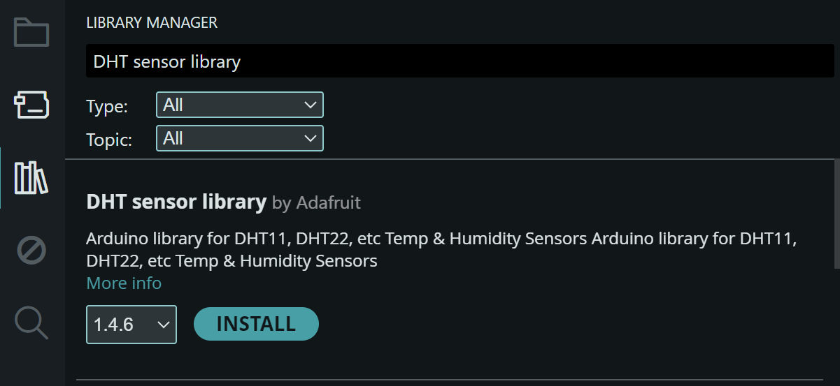

- A popup may ask to install "Dependencies" (like Adafruit Unified Sensor). Click Install All.
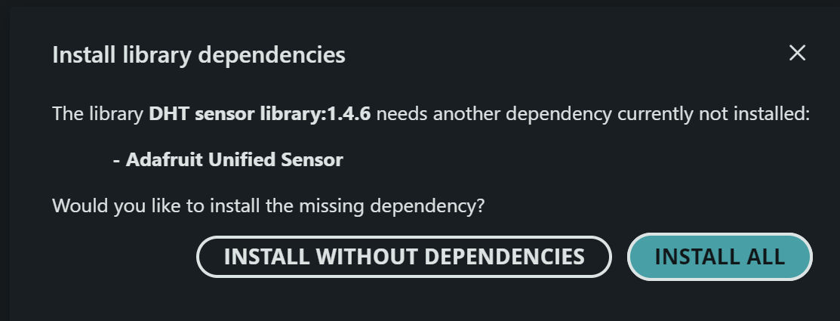

Part III. Hardware Assembly
Required Components:
- ESP32 Board
- DHT22 Sensor
- 10kΩ Resistor (Required as a "Pull-up" between VCC and Data if your DHT22 is the 4-pin bare sensor).
- Jumper Wires
Procedures:
- Connect VCC of the DHT22 to the 3V3 pin of the ESP32.
- Connect GND of the DHT22 to a GND pin of the ESP32.
- Connect the Data pin of the DHT22 to GPIO 4 (D4) of the ESP32.
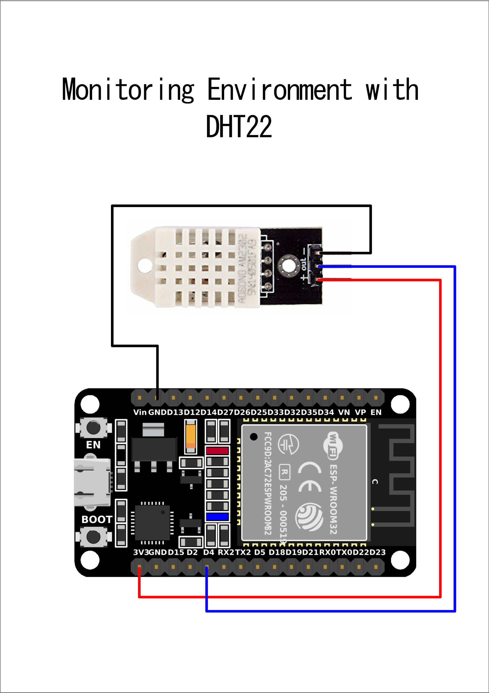
- (If using a 4-pin sensor) Place the 10kΩ resistor between the VCC and Data pins.

Part IV. The DHT22 Sketch
Procedures:
- Copy and paste the following code into a new Sketch:

#include "DHT.h"

#define DHTPIN 4 // Digital pin connected to the DHT sensor
#define DHTTYPE DHT22 // Defining the type of sensor

DHT dht(DHTPIN, DHTTYPE);

void setup() {
Serial.begin(115200);
Serial.println(F("DHT22 System Initializing..."));

dht.begin();
}

void loop() {
// Wait a few seconds between measurements (DHT22 is slow)
delay(2000);

float h = dht.readHumidity();
float t = dht.readTemperature(); // Read temperature as Celsius

// Check if any reads failed and exit early (to try again).
if (isnan(h) || isnan(t)) {
Serial.println(F("Failed to read from DHT sensor!"));
return;
}

Serial.print(F("Humidity: "));
Serial.print(h);
Serial.print(F("% | Temperature: "));
Serial.print(t);
Serial.println(F("°C"));
}

Part V. Execution & Monitoring
Procedures:
- Upload the code to your ESP32.
- Once "Done uploading" appears, go to Tools > Serial Monitor.
- Crucial Step: Set the Baud Rate in the Serial Monitor window to 115200 baud. If it's set to 9600, you will see "garbage" text.

Module VIII (L298N Driver)

Module VIII. Motor Control with L298N Driver & HW-131 Power Supply
Objective: Learn how to interface the ESP32 with the L298N Dual H-Bridge module to control the speed and direction of DC motors, utilizing the HW-131 Breadboard Power Supply to safely manage voltage levels.

Part I. Understanding the Power Dynamics
The ESP32 cannot power a motor directly. Relying on a computer's USB port to power both the ESP32 and a motor can cause voltage drops that constantly reset the controller.
- The Fix: We use the HW-131 Power Supply to create a stable 5V power hub for both the ESP32 and the L298N logic.
- Input: The HW-131 is powered via a DC barrel jack from your 7.4V battery pack.
- Output Rails: It provides independent power rails directly to your breadboard.
- Jumpers: For this setup, the yellow jumpers are used to set the output to 5V, which is safe for the ESP32's Vin pin and the L298N's logic.

Part II. Hardware Assembly & Common Ground
Crucial Safety Note: Electricity needs a complete circuit to flow. You must connect the grounds (GND) of all components together. The HW-131 automatically connects the grounds of its two rails, making it an excellent hub for a Common Ground.
Procedures:
1. Power Supply Setup (HW-131)
- Plug the HW-131 into the end of your breadboard so the pins align with the + and - power rails.
- Set the yellow jumpers on both sides to the 5V position.
- Connect your 7.4V battery to the HW-131 DC jack.
2. ESP32 Connection
- Connect the Vin pin of the ESP32 to the breadboard (+) rail (5V).
- Connect a GND pin of the ESP32 to the breadboard (-) rail.
3. Motor Driver (L298N) Connections
- Motors: Connect the wires of your DC motors to the L298N OUT1/OUT2 (Left) and OUT3/OUT4 (Right) screw terminals.
- Powering the L298N:
  - Connect the 12V terminal to the Right (+) rail (5V) of your breadboard.
  - Connect the GND terminal to the Breadboard (-) rail (Common Ground).
- Logic Wiring (Data from ESP32):
  - Remove the black jumper caps on ENA and ENB.
  - Connect ENA to GPIO 32 and ENB to GPIO 33.
  - Connect IN1 to GPIO 26 and IN2 to GPIO 27.
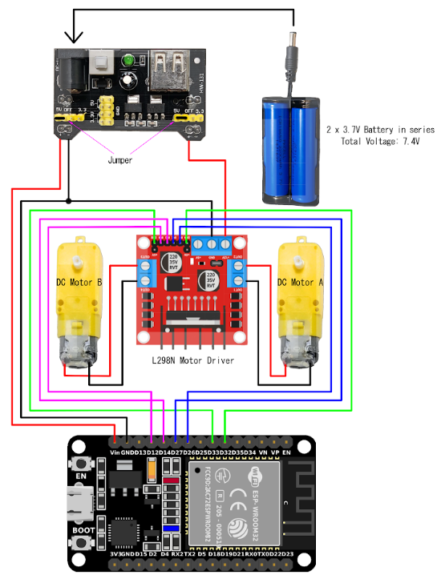
  - Connect IN3 to GPIO 14 and IN4 to GPIO 12.

Part III. The Implementation Code
This code uses PWM (Pulse Width Modulation) to control the speed of the motor via the ENA pin, while IN1 and IN2 dictate the direction.
Procedures:
- Open a new sketch in the Arduino IDE.
- Copy the code below into your Sketch Editor.

/*
* Module VIII: L298N Motor Control with HW-131
* Target Board: ESP32
*/

// 1. Define Motor Logic Pins
const int motor1Pin1 = 27; // IN1
const int motor1Pin2 = 26; // IN2
const int enable1Pin = 14; // ENA (PWM Speed Control)

void setup() {
// 2. Set pins as outputs
pinMode(motor1Pin1, OUTPUT);
pinMode(motor1Pin2, OUTPUT);
pinMode(enable1Pin, OUTPUT);

Serial.begin(115200);
Serial.println("Motor Control Initialized...");
}

void loop() {
// 3. Move DC motor FORWARD at maximum speed (255)
Serial.println("Moving Forward - Full Speed");
digitalWrite(motor1Pin1, LOW);
digitalWrite(motor1Pin2, HIGH);
analogWrite(enable1Pin, 255);
delay(2000);

// 4. STOP the motor safely
Serial.println("Motor Stopped");
digitalWrite(motor1Pin1, LOW);
digitalWrite(motor1Pin2, LOW);
analogWrite(enable1Pin, 0);
delay(1000);

// 5. Move DC motor BACKWARD at medium speed (~60%)
Serial.println("Moving Backward - Medium Speed");
digitalWrite(motor1Pin1, HIGH);
digitalWrite(motor1Pin2, LOW);
analogWrite(enable1Pin, 150);
delay(2000);

// 6. STOP the motor safely
Serial.println("Motor Stopped");
digitalWrite(motor1Pin1, LOW);
digitalWrite(motor1Pin2, LOW);
analogWrite(enable1Pin, 0);
delay(2000);
}



Part IV. Execution & Observation
Procedures:
- Verify that your HW-131 power supply is turned ON (press the physical button on the module; an LED should light up).
- Upload the code to your ESP32.
- Open the Serial Monitor at 115200 baud to watch the status updates as the motor physically spins forward, stops, and reverses at a slower speed.

Part V. Troubleshooting
- Motor only hums or buzzes: The speed (analogWrite value) is too low to overcome the physical friction of the motor, or your external battery is dying. Increase the value to 200+.
- ESP32 keeps restarting: Your motor is drawing too much power, and the grounds might not be shared correctly. Ensure the L298N GND is firmly connected to the HW-131 GND rail.
- Motor spins the opposite way than expected: Simply unscrew the motor wires from OUT1 and OUT2 and swap them around.

Module IX (Wi-Fi Web Server)

Module IX. Wi-Fi Web Server (IoT Basics)
Objective: Transform your ESP32 into a local web server. You will learn how to connect the board to your home network and host a webpage that allows you to control an LED and monitor real-time sensor data from any smartphone or computer connected to the same Wi-Fi.

Part I. Understanding Wi-Fi Modes
The ESP32 can operate in two primary Wi-Fi modes:
- Station Mode (STA): The ESP32 connects to an existing Wi-Fi network (like your home router). This is what we will use.
- Access Point Mode (AP): The ESP32 creates its own Wi-Fi network (like a hotspot) that you can connect to directly.

Part II. Hardware Assembly
Because we are adding a monitoring dashboard, we need a sensor to provide data. We will use the internal Blue LED for the control function and the LDR for the monitoring function.
Procedures:
- Set up the LDR voltage divider circuit as you did in Module IV.
- Ensure the LDR junction is connected to GPIO 34.

Part III. Setting Up the Web Server Code
To create a web server, we use the built-in WiFi.h library. We will create a simple HTML interface with a live data dashboard and two buttons: one to turn the LED ON and one to turn it OFF.
To make the dashboard update automatically, we will include a <meta http-equiv="refresh" content="5"> HTML tag so the page refreshes every 5 seconds.
Procedures:
- Open a new sketch.
- Replace "YOUR_SSID" and "YOUR_PASSWORD" with your actual Wi-Fi credentials.
- Copy and paste the code below:

#include <WiFi.h>

// 1. Replace with your network credentials
const char* ssid = "YOUR_SSID";
const char* password = "YOUR_PASSWORD";

// 2. Set web server port number to 80
WiFiServer server(80);

// 3. Variable to store the HTTP request
String header;

// 4. Assign output and input pins
const int outputPin = 2; // Using the internal Blue LED
const int ldrPin = 34; // LDR Sensor pin for the dashboard

void setup() {
Serial.begin(115200);
pinMode(outputPin, OUTPUT);
digitalWrite(outputPin, LOW);

// Connect to Wi-Fi network
Serial.print("Connecting to ");
Serial.println(ssid);
WiFi.begin(ssid, password);
while (WiFi.status() != WL_CONNECTED) {
delay(500);
Serial.print(".");
}

// Print local IP address and start web server
Serial.println("");
Serial.println("WiFi connected.");
Serial.println("IP address: ");
Serial.println(WiFi.localIP());
server.begin();
}

void loop() {
WiFiClient client = server.available(); // Listen for incoming clients

if (client) { // If a new client connects,
Serial.println("New Client.");
String currentLine = "";
while (client.connected()) {
if (client.available()) {
char c = client.read();
header += c;
if (c == '\n') {
if (currentLine.length() == 0) {
// HTTP headers always start with a response code
client.println("HTTP/1.1 200 OK");
client.println("Content-type:text/html");
client.println("Connection: close");
client.println();

// 5. Check which button was pressed
if (header.indexOf("GET /LED/on") >= 0) {
digitalWrite(outputPin, HIGH);
} else if (header.indexOf("GET /LED/off") >= 0) {
digitalWrite(outputPin, LOW);
}

// 6. Read Sensor Data
int currentLightLevel = analogRead(ldrPin);

// 7. Display the HTML web page
client.println("<!DOCTYPE html><html>");
client.println("<head><meta name=\"viewport\" content=\"width=device-width, initial-scale=1\">");

// This line automatically refreshes the webpage every 5 seconds to update the sensor reading
client.println("<meta http-equiv=\"refresh\" content=\"5\">");

client.println("<style>html { font-family: Helvetica; text-align: center;}");
client.println(".button { background-color: #4CAF50; border: none; color: white; padding: 16px 40px;");
client.println("text-decoration: none; font-size: 30px; margin: 2px; cursor: pointer;}</style></head>");

client.println("<body><h1>Smart Agri Dashboard</h1>");

// Inject the sensor data into the HTML
client.println("<h2>Environment Monitor</h2>");
client.print("<p style=\"font-size: 24px;\">Current Light Level: <strong>");
client.print(currentLightLevel);
client.println("</strong> / 4095</p><hr>");

// Inject the Control Buttons
client.println("<h2>Equipment Control</h2>");
client.println("<p><a href=\"/LED/on\"><button class=\"button\">ON</button></a></p>");
client.println("<p><a href=\"/LED/off\"><button class=\"button\" style=\"background-color:red\">OFF</button></a></p>");
client.println("</body></html>");

client.println(); // The HTTP response ends with another blank line
break;
} else {
currentLine = "";
}
} else if (c != '\r') {
currentLine += c;
}
}
}
header = "";
client.stop(); // Close the connection
Serial.println("Client disconnected.");
}
}

Part IV. Execution and Accessing the Server
Procedures:
- Upload the code to your ESP32.
- Open the Serial Monitor (115200 baud).
- Wait for the message: "IP address: 192.168.x.x". Write this number down.
- Open a web browser on your phone or laptop (ensure it is on the same Wi-Fi).
- Type the IP address into the URL bar and hit Enter. Cover the LDR with your hand; you will see the number on the dashboard drop the next time the page auto-refreshes.

Part V. Troubleshooting
- Serial Monitor shows only dots (......): Your SSID or Password might be wrong, or your router is blocking the connection.
- Webpage won't load: Make sure your phone/laptop is on the exact same Wi-Fi network as the ESP32.
- IP Address is 0.0.0.0: The board didn't get an IP from the router. Try resetting the ESP32 using the EN button.

Module X (SMTP)

Module X. Automated Sensor Alerts via SMTP
Objective: Program the ESP32 to act as an SMTP (Simple Mail Transfer Protocol) client that automatically sends a secure email notification when a hardware sensor (LDR) detects a drastic change in ambient light.

Part I. Generating a Google App Password
To allow the ESP32 to send emails through Google's servers securely without exposing your main password, we must generate a dedicated App Password.
Procedures:
- Log in to the Google account you wish to send emails from and navigate to Manage your Google Account.
- Go to the Security tab on the left sidebar.
- Ensure that 2-Step Verification (2SV) is enabled.
- Under the "How you sign in to Google" section, select 2-Step Verification or access the link https://myaccount.google.com/signinoptions/two-step-verification
- Scroll to the bottom of the page and select App passwords or access the link below https://myaccount.google.com/apppasswords
- Provide a custom name for the application (e.g., "ESP32_Instrumentation_Node") and click Create.
- A 16-character passcode will appear in a yellow box. Copy this exact 16-character string. You will paste this into your Arduino code.

Part II. Assembling the LDR Hardware Circuit
Follow the instruction in Module IV (LDR) https://docs.google.com/document/d/170G1Daqi7okVkJQQcL4bjHP7jFjB6nJPPeuaKTJ9M9Y/edit?tab=t.58i236x31gce

Part III. Installing the Required Library
Standard Arduino libraries cannot handle the complex SSL/TLS encryption required by Google's SMTP servers. We will use a specialized library.
Procedures:
- Open the Arduino IDE.
- Open the Library Manager from the Sidebar (or navigate to Sketch > Include Library > Manage Libraries).
- In the search bar, type ESP Mail Client.
- Locate the library authored by Mobizt and click Install.

Part IV. The Sketch (Code)
Procedures:
- Copy the code below into your Sketch Editor.
- Replace YOUR_WIFI_SSID and YOUR_WIFI_PASSWORD with your local network credentials.
- Replace SENDER_EMAIL@domain.com and the APP_PASSWORD with the credentials generated in Part I.
- Replace RECIPIENT_EMAIL@domain.com with the address where you want to receive the alert.
#include <Arduino.h>
#include <WiFi.h>
#include <ESP_Mail_Client.h>

#define WIFI_SSID "YOUR_WIFI_SSID"
#define WIFI_PASSWORD "YOUR_WIFI_PASSWORD"

#define SMTP_HOST "smtp.gmail.com"
#define SMTP_PORT 465 // Secure SSL/TLS port

// The email account sending the alert
#define AUTHOR_EMAIL "SENDER_EMAIL@domain.com"
#define AUTHOR_PASSWORD "YOUR_16_CHAR_APP_PASSWORD"

// The email account receiving the alert
#define RECIPIENT_EMAIL "RECIPIENT_EMAIL@domain.com"

SMTPSession smtp;
const int ldrPin = 34; // Analog pin connected to the LDR voltage divider
bool alertSent = false;

void setup() {
Serial.begin(115200);
WiFi.begin(WIFI_SSID, WIFI_PASSWORD);

Serial.print("Connecting to Wi-Fi");
while (WiFi.status() != WL_CONNECTED) {
Serial.print(".");
delay(300);
}
Serial.println("\nConnected with IP: ");
Serial.println(WiFi.localIP());

// Enable debugging to see the SMTP communication in the Serial Monitor
smtp.debug(1);
}

void loop() {
int ldrValue = analogRead(ldrPin);

// Trigger threshold: If exposed to bright light
if (ldrValue > 3000 && !alertSent) {
Serial.println("High light threshold exceeded! Sending alert...");
sendEmailAlert(ldrValue);
alertSent = true; // Set flag so it doesn't spam your inbox
}

// Reset the flag once the enclosure is closed / it gets dark again
if (ldrValue < 2000) {
alertSent = false;
}

delay(1000);
}

void sendEmailAlert(int currentReading) {
ESP_Mail_Session session;
session.server.host_name = SMTP_HOST;
session.server.port = SMTP_PORT;
session.login.email = AUTHOR_EMAIL;
session.login.password = AUTHOR_PASSWORD;
session.login.user_domain = "";

SMTP_Message message;
message.sender.name = "ESP32 Instrumentation Node";
message.sender.email = AUTHOR_EMAIL;
message.subject = "CRITICAL: Light Threshold Alert";
message.addRecipient("Admin", RECIPIENT_EMAIL);

// Construct the email body
String emailBody = "Warning! The instrumentation sensor detected a high light event.\n\n";
emailBody += "Current LDR Reading: " + String(currentReading) + " / 4095\n";
emailBody += "Please check the equipment immediately.";

message.text.content = emailBody.c_str();

if (!smtp.connect(&session)) return;
if (!MailClient.sendMail(&smtp, &message)) {
Serial.println("Error sending Email, " + smtp.errorReason());
} else {
Serial.println("Email sent successfully!");
}
}

Part V. Execution and Accessing the Results Procedures:
- Upload the code to your ESP32.
- Open the Serial Monitor (115200 baud).
- Wait for the message confirming the Wi-Fi connection.
- Trigger the sensor: Shine a bright flashlight directly onto the LDR so the analog reading spikes above 3000.
- Watch the Serial Monitor. You will see the ESP32 negotiate the SSL handshake with Google's servers.
- Look for the "Email sent successfully!" message. Check your receiving inbox to view the automated alert.
- Cover the LDR with your hand to drop the reading below 2000, resetting the system for the next alert.
Part VI. Troubleshooting
- LDR Value is Always 0 or 4095: Check your wiring. Ensure the 10k resistor is properly grounded and the junction wire is securely connected to Pin 34.
- Error 535 (Authentication Failed): Double-check that your 16-character App Password has no spaces in the code. Ensure you are using the exact email address associated with that App Password.
- Failed to connect to server / Connection Refused: Check if your local network or firewall is blocking outbound traffic on port 465.
- Serial Monitor shows only dots (......): Your SSID or Password might be wrong, or your access point is offline. Ensure the ESP32 is within range of your Wi-Fi router.

Multimeter

What is a Multimeter?
It is one tool that does three main jobs:
- Voltmeter (V): Measures "pressure." Is your 7.4V battery actually full?
- Ohmmeter (Ohms): Measures "resistance." Is your 10k resistor the right one?
- Continuity: Measures "connection." Is there a broken wire or a "short" in your breadboard?
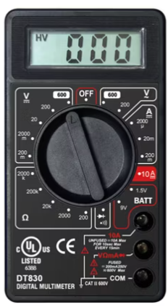
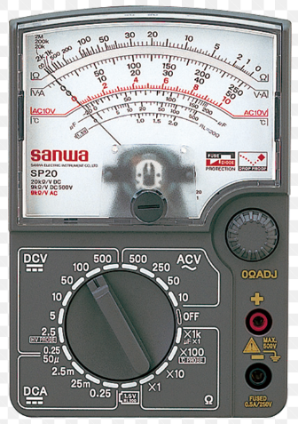
The Big Difference: Analog vs. Digital

Feature | Analog (Old School) | Digital (Modern)
Reading it | You watch a needle move. | You read a number on a screen.
Accuracy | Hard to be exact; you have to "guess" between lines. | Very exact; shows you "3.29V" clearly.
Ease of Use | You must pick the right "range" or the needle might break. | Most are Auto-Ranging—the tool finds the range for you.
Best For | Watching values that fluctuate rapidly (wobbling needle). | Everything else! Checking sensors, batteries, and code.

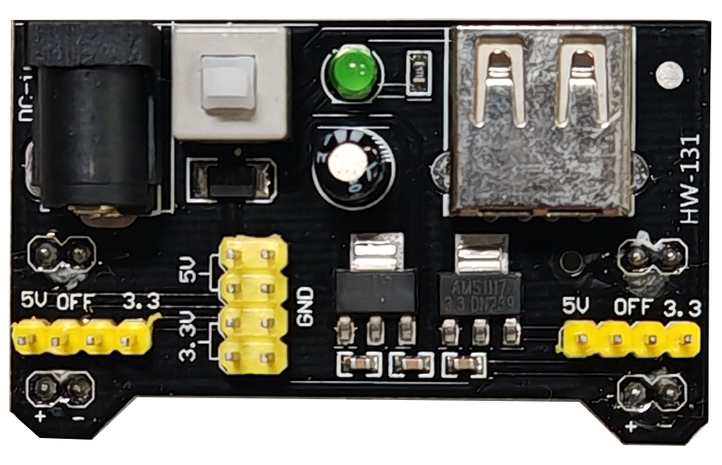
What is HW-131?

The HW-131 is a breadboard power regulator that sits directly on the power rails of your breadboard.

- Input: You can power it via a 12V DC barrel jack or a USB cable.
- Output: It has two independent sets of pins that can be set to 5V or 3.3V using yellow jumpers.
- Switch: It has a physical ON/OFF button, which is much safer for participants than constantly unplugging wires.

How to Connect it for your ESP32 Project
To use this with your specific instrumentation modules, follow this setup:
- Mounting: Plug the module into the very end of your breadboard so the pins align with the + and - rails.
- Setting the Jumpers: * Set the Left Side jumper to 3.3V to power your ESP32 and LDR.
  - Set the Right Side jumper to 5V if you need to power the L298N logic or the Ultrasonic sensor.
- Wiring the ESP32: * Connect the breadboard's (+) rail to the Vin or 3V3 pin of the ESP32.
  - Connect the breadboard's (-) rail to a GND pin.

